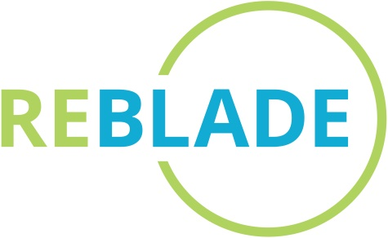
MEDIA RELEASE: 25 November 2022

For immediate use

ReBlade secures Innovate UK funding to help turn wind turbine blade waste into public realm infrastructure

- £50k grant funding awarded by Innovate UK’s Fast Start competition to support innovative SMEs
- Project will establish a materials testing framework for decommissioned turbine blades to check their suitability for remanufacturing for as public realm infrastructure
- Project praised for its focus on practicality and scalability

A Scottish start-up company is on its way to becoming a global leader in repurposing wind turbine blades after securing funding from the UK’s national innovation agency for a project titled ‘Certifying Wind Turbine Blade Derived Products’.

The grant from Innovate UK’s sought after Fast Start competition will allow the development of a materials testing framework and safety certification regime for decommissioned wind turbine blades.

The framework, to be developed by independent composite experts, will open the door for the UK’s decommissioned turbine blades to be transformed into public realm infrastructure, such as shelters and benches.

The funding was awarded after ReBlade responded to a competitive challenge issued by Innovate UK earlier this year calling for affordable, adoptable, and investible solutions for reducing environmental impact.

Fiona Lindsay, Technical Director and co-founder of ReBlade, said that award evidences high-level backing for sustainable approaches to blade disposal.

“Wind turbine blades are notoriously difficult to recycle and finding uses for them has been a known challenge within the renewables industry for years. It’s a challenge I was personally keen to address, because as the first generation wind turbines I helped to put up early in my career start to come down, I want to help find a sustainable solution and a circular end destination for the material.

“I’m delighted that Innovate UK has recognised the potential for circular disposal of these blades by backing this project. Turbine blades are incredibly strong and robust components, and this new research will equip us with structural integrity checks and tests to make informed decisions about the circular potential and reuse viability of each blade.”

ScottishPower Renewables is currently working with ReBlade to explore options available in repurposing its end-of-life blades. Barry Carruthers, Managing Director for SPR Onshore (UK & Ireland) said:
“Congratulations to ReBlade on this award. We pride ourselves on being a responsible and sustainable renewables provider and the funding will help inform the work underway with ReBlade to explore the potential for giving turbine blades a new lease of life and a different way of making a green contribution to society.”

Scottish Renewables, the voice of Scotland’s renewable energy industry, has also welcomed the award, highlighting it is as yet another example of Scottish based SMEs leading the way in innovating for the industry.

Emma Harrick, Head of Energy Transition and Supply Chain at Scottish Renewables, said: “It’s great news that the exceptional work ReBlade does in sustainable turbine blade decommissioning has been recognised by Innovate UK’s Fast Start competition.

“With a truly innovative approach, ReBlade has made a significant impact in the circular economy and is an exciting example of how adopting a circular approach can present a great opportunity for many businesses as Scotland transitions to net-zero.

“I look forward to seeing ReBlade continue to grow and play a key role in this area of our industry.”

The six month innovation project will conclude in April with plans for the blade-derived items expected to be unveiled in early 2023.

-ENDS-

For further information please contact:
Steven Lindsay steven@reblade.co.uk / 07729 564 222

Photos:
A selection of photos are available on request.

Notes to Editors
- ReBlade is the first specialist wind turbine and nacelle decommissioning service in the UK.
- Launched in 2021, the company draws on 30+ years of combined experience in wind turbine blade maintenance and windfarm site design.
- ReBlade have been announced as finalists in the Scottish Green Energy Awards in the category of Sustainable Development, and recently won the category of Technology & Innovation in the Holyrood Green Giant Awards.
- Further information can be found at www.reblade.co.uk

